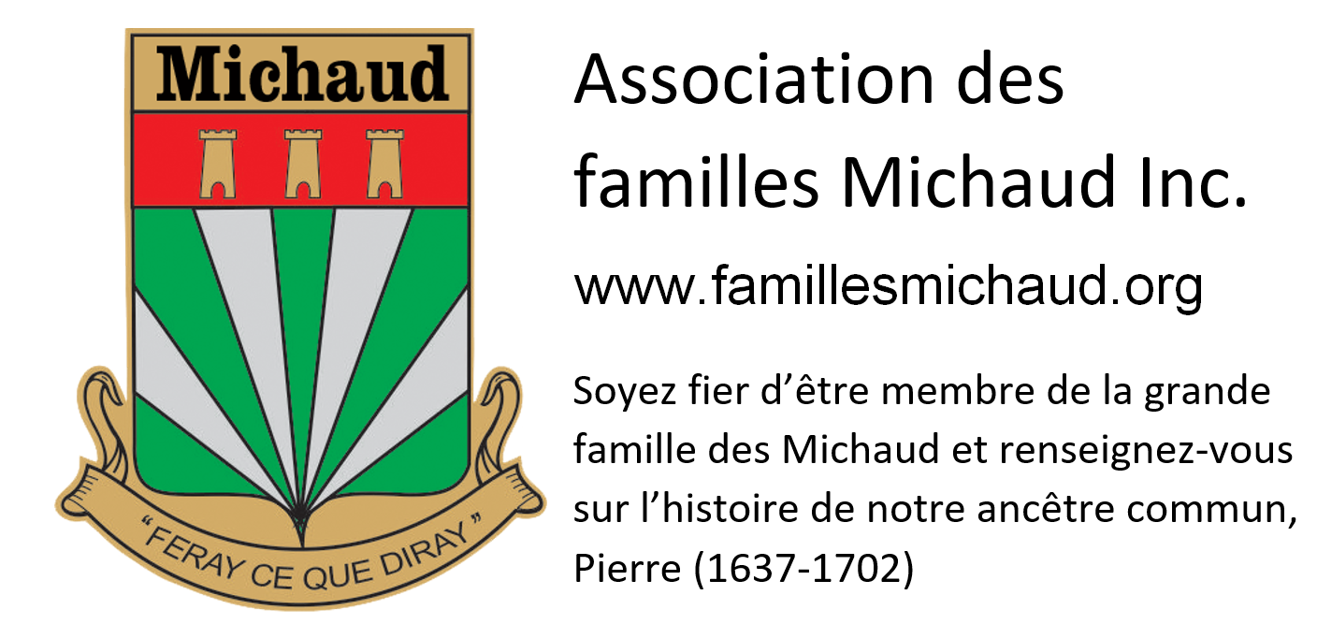GENEALOGICAL INFORMATION

If you wish (it’s not "obligatory" to become a member), you can provide us with the genealogical data that you know of your family. This will be very useful for us to complete our database and may allow us to establish missing links.
Note: if you are not sure about any information, please do not enter it at all.

you
First name |  |  |  | Name |  |  |  |  | Mr | Mrs
Are you or have you ever been a member of the Michaud association? |  | Yes | No |  | Member number  (if you know) : |  |  | Phone ( ) -
Birth (date YYMMDD) and place

Your main occupation (currently or before retirement)

Father’s first name |  |  |  | Father’s name
Father’s birth and place

Date of death of your father and place

Mother’s first name |  |  |  | Mother’s name
Mother’s birth and place

Date of death of your mother and place

Date (YYMMDD) and place of marriage of my parents

Brothers (name, birth) from the same father and mother  - (Write the sixth name and the following on the back if required) |  |  |  |  |  |  | Date (YYYY-MM-DD) and place of death

HUSBAND OR WIFE
Marital status
MARRIED COMMUN LAW PARTNER SINGLE WIDOW RELIGIOUS SEPARATED/DIVORCED
First name and name of your wife or husband |  |  | Date (YYYY-MM-DD) and place of birth
 |  |  | Date (YYYY-MM-DD) and place of death
His (her) main occupation (currently or before retirement)

Date (YYMMDD) and place of your marriage (If it's happened)

First name and name of each of the children from your union, and birth |  | Date (YYYY-MM-DD) and place of death
Note : Complete another sheet titled "Your wife or husband" if you wish to inform us of other children you have from another union.
His (her) father’s first name and name |  |  | Date (YYYY-MM-DD) and place of birth
 |  |  | Date (YYYY-MM-DD) and place of death
His (her) mother’s first name and name |  |  | Date (YYYY-MM-DD) and place of birth
 |  |  | Date (YYYY-MM-DD) and place of death

grandpARENTS (parents OF YOUR FATHER)
Name of your grandfather | Date (YYYY-MM-DD) and place of birth
 | Date (YYYY-MM-DD) and place of death
Maiden name of your grandmother | Date (YYYY-MM-DD) and place of birth
 | Date (YYYY-MM-DD) and place of death
Date (YYMMDD) and place of marriage

GREAT-GRANDPARENTS (GRANDSPARENTS OF YOUR FATHER)
Name of your great grandfather | Date (YYYY-MM-DD) and place of birth
Maiden name of your great grandmother | Date (YYYY-MM-DD) and place of birth
Date (YYMMDD) and place of marriage

grandpARENTS (parents OF YOUR mother)
Name of your grandfather | Date (YYYY-MM-DD) and place of birth
 | Date (YYYY-MM-DD) and place of death
Maiden name of your grandmother | Date (YYYY-MM-DD) and place of birth
 | Date (YYYY-MM-DD) and place of death
Date (YYMMDD) and place of marriage

GREAT-GRANDPARENTS (grandsparents OF YOUR mother)
Name of your great grandfather | Date (YYYY-MM-DD) and place of birth
Maiden name of your great grandmother | Date (YYYY-MM-DD) and place of birth
Date (YYMMDD) and place of marriage

SEND THIS FORM TO:
By mail :
Association des Familles Michaud Inc.
a/s Alain Michaud
263 rue de la Normandie
Rimouski QC CANADA G5N 1H9
Or, after printed, completed and scanned, by email attachment to presidence@famillesmichaud.org

- If you are a member in good standing, you will find this information Direct ancestry only) in a few months in the genealogical database of our association, accessible free online as long as you are a member.

- The AFMI genealogist reserves the right not to enter information which appears to him contradictory or inaccurate, according to his own research.

- Reminder: If you are unsure of any information, simply do not enter it. In genealogy, it is better not to have information at all rather than perpetuate an erroneous one.

____
V. 2022/05

