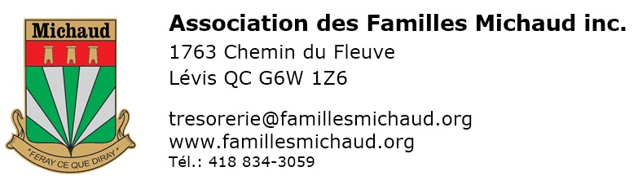RENEWAL FORM
For dues expiring on March 31, 2024

Three ways to pay for your subscription :
- The easiest by our site by our site https://famillesmichaud.org/en, section « Shopping online / Renew your subscription ». Visa, MasterCard or PayPal account OR
- Print, complete manually and mail this form with your check to Neuville OR
- Make an Interac transfer using the email tresorerie@famillesmichaud.org

Information about the actual member
First Name |  |  |  |  |  |  |  | Name |  |  |  |  | Mr. |  |  | Mrs.
Adress |  |  |  |  |  |  |  |  |  |  |  |  | N° appartement
City |  |  |  |  |  |  |  | Province or State |  |  |  |  | Postal Code
Phone |  |  |  |  |  |  |  | E-mail  By providing your e-mail, you automatically agree to subscribe to the association's e-newsletter.
Birth (YYMMDD) |  |  |  |  |  | IMPORTANT : Write your membership number |  |  |  |  | Correspondence language |  | FRENCH ENGLISH

CONTRIBUTION (CANADA)
Regular member |  |  | CAN $30  Until March 31, 2025  CAN $80  Until March 31, 2027 |  |  |  | Limited time offer: receive a birthday calendar worth CAN $20 with a contribution until 2027. |  |  |  |  | Benefactor member  Additional donation |  | CAN $60  Until March 31, 2025  _____ $
Lifetime Member |  |  | CAN $375  In one payment |  |  |  | Non transferable to husband or wife. |  |  |  |  | Benefactor and donor: check the box if you do not want your name to appear in the Brelan

contribution (outside canada)
For outside Canada, regardless of the country, please pay in U.S. dollars
Regular member |  |  | US $35  Until March 31, 2025  US $95  Until March 31, 2027 |  |  |  | Limited time offer: receive a birthday calendar worth CAN $20 with a contribution until 2027. |  |  |  |  | Benefactor member  Additional donation |  | US $70  Until March 31, 2025  $ _____
Lifetime Member |  |  | US $400  In one payment |  |  |  | Non transferable to husband or wife. |  |  |  |  | Benefactor and donor: check the box if you do not want your name to appear in the Brelan

MAIL THIS FORM WITH A CHECK PAYABLE TO “ASSOCIATION DES FAMILles MICHAUD INC.” »
Association des Familles Michaud Inc. a/s du trésorier, 1763 chemin du Fleuve, Lévis QC G6W 1Z6
SIGNATURE |  |  |  |  |  |  |  |  |  | Date
- Including subscription to Le Brelan
- New: an updated and more complete website in English at: www.famillesmichaud.org/en/

ACCESS TO ONLINE SERVICES (FREE)
Check the situation(s) corresponding to you
I refuse to have my name published in the association's journal.
I do not have an access code (or I do not remember) and I want access to the exclusive members section on https://famillesmichaud.org/en/
I will be satisfied with the online version of the Brelan. Please do not send me hard copies by mail.
Note : The nominative information provided is considered confidential by the association, as required by Law 25 of Quebec.

